Prices and *Regateo*

In Spain, prices in department stores (***almacenes***) and other stores (***tiendas***) are ***precios fijos*** (set prices). However, you will also find certain markets (***mercados***) in both Spain and Latin America where you can buy flowers, clothing, furniture, antiques, music, and souvenirs. In some of these markets, the prices are not fixed; rather, it is necessary and even expected to bargain (***regatear***) with the vendor in order to get a good price. The most famous Spanish market of this kind is El Rastro, which is held on Sundays and public holidays in Madrid. If you visit the Rastro and are looking to bargain, the best time to go is first thing in the morning. Although some tourists find bargaining tiresome, most think it's fun and an excellent way to put their Spanish to use!

- Adapted from *Sol y viento* p. 118

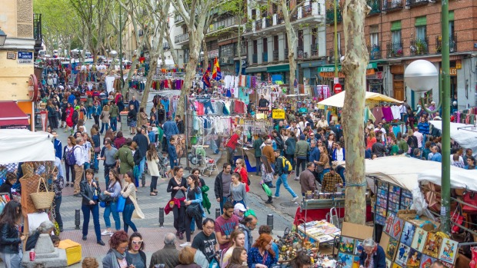

El Rastro- Madrid